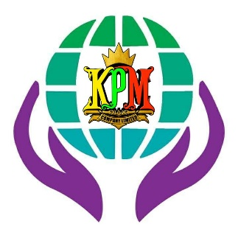

**KHAING PARAMI COMPANY LOGO ပါ။**

**ABOUT US**

Our travel company was established in 2023 with the aim of providing reliable and trustworthy services for both domestic and international travelers. We are committed to delivering memorable travel experiences through responsible and dedicated service.

Our range of services includes flight ticket reservations, hotel booking and transfers, guided tours, and complete travel itinerary management. Our team continuously strives to create comfortable, safe, and enjoyable journeys for every travel enthusiast, ensuring a truly unforgettable travel experience.

**CONTANCT US**

kaimyanmar2018@gmail.com

+9595416199

**OUR TEAM**

**BACKGROUD အတွက်ပုံတွေပါ။**







**FOUNDER DAW WAI LI KHAING ရဲ့ပုံပါ။**



